**Managing Your Child’s Technology Use**

*The smartphone is the best bargaining chip ever created. A teen would sooner die than loose his/her phone. USE THIS AS LEVERAGE. I tell my teens: I pay for it; it’s only on loan to you.*

**Internet and Device Monitoring Apps:** (Content Watch Net Nanny, Norton Family Premier, Kaspersky Safe Kids, and Find My Friends)

**Net Nanny** https://www.netnanny.com/

Families can use Net Nanny to protect users from pornography, online predators, cyber bullying, and other threats that compromise online safety. Net Nanny's award-winning technology filters, monitors, and blocks unsafe materials while allowing kid’s access to the Internet. Unlike other parental controls that simply block a list of websites, Net Nanny's dynamic filter scans and analyzes each web site to determine if it is appropriate for your child, based on your unique customization. It can even mask profanity but let the site pass; ensuring kids are protected while they navigate the Internet.

* **Internet Filter**
* **Time Management**
* **Social Media Monitoring**
* **Social Media Monitoring**
* **Personal Accountability**
* **Block Pornography**
* **Profanity Masking**
* **Alerts and Reporting**
* **Remote Management**

**Norton Family Premier:** Yearly for Microsoft Windows, Mac, iOS, Android OR Norton 360 Deluxe includes protection for 5 devices.

| Key Technologies | |
| --- | --- |
| * Know at a glance when and where your kids spend time online. * Use simple settings to make the Web safe for kids to explore. * Easily protect kids’ private information and online reputations. * Gain valuable insights that lead to open, informed conversations. | * Help teach balance and healthy habits without taking away kids’ freedom. * Easily protect all your kids’ devices with a single solution. * Now your purchase of Norton Security with Backup also includes Norton Family. Get these family-friendly features and the protection Norton is known for, all in a single product |

Key Features

* Help Balance Time Spent Online: Manage your kids’ time spent online so you know when it’s time to encourage having some offline fun.
* Help your kids explore the Web safely. - Keeping kids safe online shouldn’t be the end of their freedom; it should be the start of open and ongoing conversations about how to build safe and smart online habits.
* Teach habits that protect kids from sharing too much online. - Safe and healthy online habits start with honest conversations. Our helpful tools allow you to see kids’ online activities at a glance or be notified by email alerts, so you know when it’s time to talk.

**Web Supervision** – Lets your kids explore the Web freely, while keeping you in the know about which sites they visit and giving you tools to help them avoid unsuitable content.

**Social Network Supervision**1 – Provides insight into your child's social media use, including how frequently they log in to Facebook from their PC, and the name and age they use on their profile.

**Search Supervision**2 – Shows you the words, terms and phrases your kids search for on their PC and iOS devices, giving you insights into their interests and helping you keep them safe from inappropriate content.

**Personal Information Protection**1 – Helps your children avoid accidentally giving out sensitive personal information from their computer, including phone number, address, school they attend or email address.

**PC Time Supervision** – Stay on top of how much time your kids spend online while they are on their PC. You can easily set time limits or schedule what times of the day or week your kids can connect.

**Email Alerts** – Tells you when your kids attempt to visit a blocked site so that you can start a conversation about appropriate content.

**Access Request** – Enables open discussion, letting your kids send you a note from within Norton Family if they want to ask for an exception to a blocked site or a House Rule.

**Parent Mobile App**3 – From your Android™ mobile device, stay in the loop about your kids' online activities and adjust settings while you're on the go.

**Video Supervision**4 – Lists the YouTube videos your kids watch on their PC and iOS devices, even letting you view a snippet of each video, so you know when you need to talk.

**Location Supervision**5 – Keeps you in the loop about where your kids are, letting you map the location of their mobile device.

**Mobile App Supervision**3 – Shows you which apps your kids have on their Android mobile devices and lets you choose which apps they use.

**Text Message Supervision**6 – Keep an eye on your kids' Android SMS text conversations and control who your kids can text.

**Monthly/Weekly Reports** – Receive detailed reports of what your kids are doing online, right in your inbox. **Android Time Supervision** – Control how much time your kids spend online using their Android mobile devices.

System Requirements

Norton Family Premier is available for Windows, Android, and iOS. You must have an Internet connection to install and use Norton Family Premier. When you are connected to Internet, Norton Family automatically checks for any new updates and downloads them. It lets you view the alerts and configure some of the House Rule settings for your child.

**Kaspersky Safe Kids** https://usa.kaspersky.com/safe-kids

When parents activate Kaspersky Safe Kids on children’s devices, they’ll get a good set of parental control tools, plus an opportunity to be aware of the kid's interests to support them and establish trustful relationships. Helps you protect your children in the digital world – on their IPhone, IPad, Mac Computers, PC’s and more.

**Security Cloud Version:**

Install Kaspersky Safe Kids on a set number of the devices children use.

* Monitors & reports on your child’s web activity & device usage.
* Shows your children’s location on a map.
* Helps you define & monitor Safe Areas.
* Sends you real-time alerts & notifications for suspicious activity.
* Makes it easy to monitor public Facebook activity.

**Other Apps**

**Find My Friends**

This app will be an easy sell to most teens; it’s a fun way for them to know where their friends are and the perfect way for you to keep an eye on them. Find My Friends uses GPS location networks to show on a map exactly where your friends are. You have to give people permission to follow you, and then you can find out exactly where they are at any time of the day or night.

This is a great way to check that they are where they say they are. This app is **FREE** and available for IPhones and Android.

**Duolingo**

Whether your teen is studying a second language at school or you just want to encourage them to learn, Duolingo is a fun and interactive app that helps you learn Spanish, French, German, Portuguese or Italian. Perfect for long commutes to school, this app will stimulate the brain cells and get your teenager practicing a new language. Duolingo is **FREE** and optimized for IPhones with IOS 5.0 or later.

**Allowance Bank of Mom and Dad**

Allowances is a **FREE** app that helps parents keep track of their children's money and automates management of allowances. Help build kids' financial literacy by tracking where their money goes.

Features

• Supports multiple children  
• Automated allowance on weekly or monthly schedule for each child  
• Custom currency format  
• No online registration required

**Chore Bank**

Chore Bank can be used to keep track of your child's allowance, completion of chores, and spending money. It is your own personal 'Bank of Dad'...or Mom. It includes many features that will encourage your children to get all their chores done. Set up a chore list and assign a monetary value to each chore. When a child completes a chore you simply check off the chore and the value of the chore is added to that child's account. You can make deposits to a child's account to handle random 'gifts' or unexpected earnings. You can make withdrawals from the account, when your child wants money for something you would not ordinarily pay for yourself. You can set an interest rate. This is a great way to teach your child the value of saving money.  
If you upgrade to **Chore Bank Pro**, you also get;

* Chore Scheduling.
* Printable Chore Calendar.
* Text message reminders to kids when their chores are scheduled.
* Assign consequences for chores not done.
* Create custom chore lists for each child.
* Two parents can share one account.

**Find My Family, Friends & Phone - Life360 Locator**

* View the real-time location of friends or family members on a private map.
* Receive real-time alerts when friends or family arrive or leave home, work, and school.
* Share photos and text messages with our secure, private chat.
* See past location history for your Circle.
* See information after each drive to improve driving safety.
* Protect your family while they’re driving with our Crash Detection Service.
* Track a lost or stolen phone.

Use GPS to find Friends and Family  
Life360’s Family & Friend Locator uses state-of-the-art GPS location data to report the real-time whereabouts of your friends and family. Simply install the Family & Friend Locator on everyone’s phone. Once registered, each member appears as a unique icon on the map so you’ll always know where your family members are.  
  
No need to send text messages asking “When will you be home?” The Life360 Family & Friend Locator tells you! Create Geofence zones around your home, work, school, or anywhere you visit regularly. Whenever someone in your Circle arrives or leaves those locations, you’ll get a notification.

Set up and use Find My Friends App

Use Find My Friends to easily locate your friends and family from your iPhone, iPad, iPod touch, Apple Watch, or on iCloud.com.

## Before you Start

* Update your iPhone, iPad, or iPod touch to iOS 8 or later.
* Update your Apple Watch to watchOS 3 or later.
* If it's not already on your device, download the Find My Friends app.
* Make sure that the web browser on your Mac or PC is up to date.

## Set up

If your iPhone, iPad, or iPod touch is using iOS 9 or later, Find My Friends is automatically installed. If your device is using a version of iOS 8, install the free Find My Friends app. When you sign in to iCloud on your device, you automatically sign in to Find My Friends with your Apple ID.

If you want to get Find My Friends notifications on your Apple Watch, go to the Apple Watch app on your iPhone. Then go to the My Watch tab, tap Notifications, scroll down, tap Find Friends, and tap to turn on Mirror iPhone alerts. If you're using watchOS 4 or later, you can also turn notifications on from your Apple Watch. Go to Settings > General > Location Services. Then turn on Share My Location.

You can also use Find My Friends on iCloud.com or with Family Sharing to share your location with your family.

## Add a Friend

To use Find My Friends, make sure your friends have Find My Friends on their device too. You can only add friends from Find My Friends on your iPhone, iPad, or iPod touch.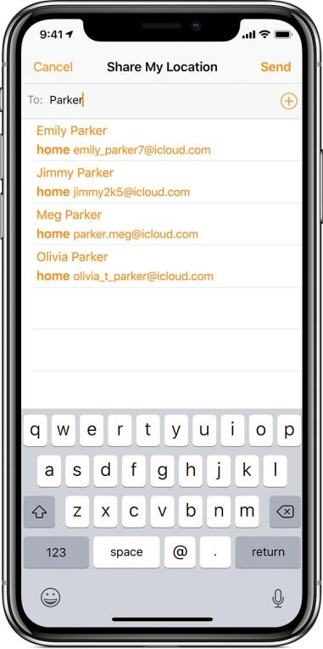

1. Open Find My Friends.
2. Tap Add.
3. Choose a friend or enter their email address, then tap Send or Done to send the request.

After your friend agrees to share their location, you can see their location in a list or on a map in the Find My Friends app, or on iCloud.com.

If you want, you can choose which email address to use when sending requests to friends:

* On your iPhone or iPod touch, tap Me > Send As.
* On your iPad, tap List > Me > Info > Send As.

If you don't want to get friend requests:

* On your iPhone or iPod touch, tap Me > turn off Allow Friend Requests under Invitations.
* On your iPad, tap List > Me > turn off Allow Friend Requests under Invitations.

With the Find My Friends app on iCloud.com, you can only see your friends and their location or change settings for sharing your location. To add friends, you need to use an iOS device.

**Hide Your Location**

You can hide or stop sharing your location with your friends. Just follow these steps:

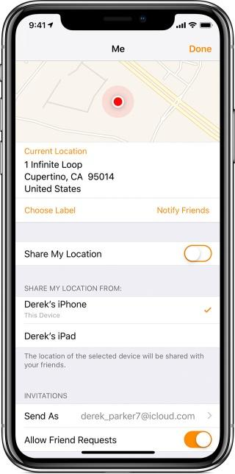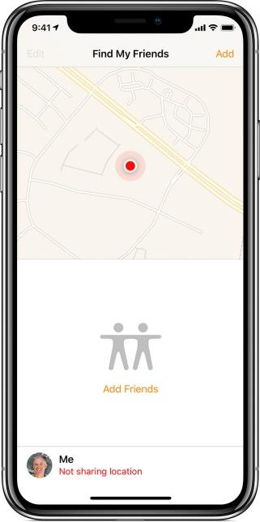



## Stop Sharing Your Location

If you don't want your friends to see your location in Find My Friends, you can stop sharing from the app on your iOS device or on iCloud.com. You can still see the location of your friends, but your friends see Location Not Available when they try to locate you.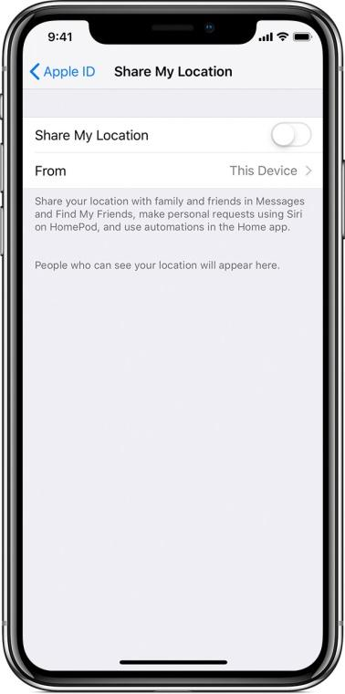

On your iPhone, iPad, or iPod touch:

1. Go to Settings > [your name].
2. If you're using iOS 12, tap Share My Location. If you're using an earlier version of iOS, tap iCloud > Share My Location.
3. Turn off Share My Location.

On iCloud.com:

1. Sign in to iCloud.com and open Find My Friends.
2. Select Me.
3. Deselect Share My Location.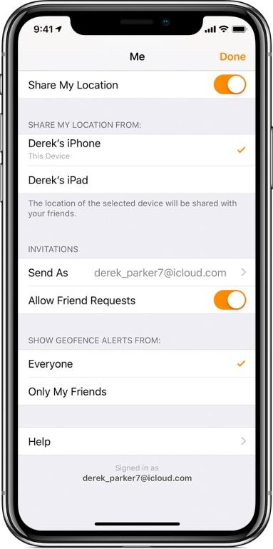

## Use Find My Friends on Multiple Devices

You can use Find My Friends on any iPhone, iPad, iPod touch, or Apple Watch that you own. However, only one iOS device and any paired cellular Apple Watch can send your location to your followers. You can choose which one to use in Find My Friends:

* On your iPhone or iPod touch, tap Me, then tap a device under Share My Location From.
* On your iPad, tap List > Me > Info, then tap a device under Share My Location From.

This choice only appears when you're currently signed in to Find My Friends on multiple devices.

## Send and Accept Location Requests

Your friends can send you a request to follow your location. If you accept someone's request, that person can then see your location. If you want to see that person's location, you must invite them, and they must accept your invitation.

If you accept a request from a friend that you’re not following, a follow request is automatically sent to your friend.

## Friends and Followers Limits

* You can follow up to 100 friends. Up to 100 friends can follow you.